5. Hand Pass
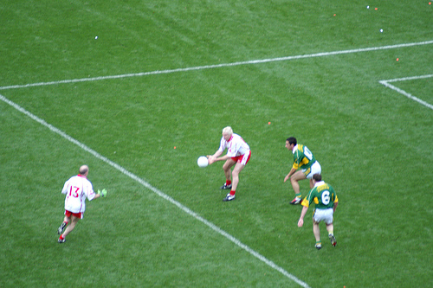

- Introduce
- Demonstrate
- Execute
- Attend

Support the ball in the palm of one hand

The Hand Pass is a basic technique in Gaelic Football used to pass the ball over a short distance. The technique involves supporting the ball in one hand and striking it with the open free hand.

Extend the striking hand back

Look out for:
- Hitting with the wrong part
- Not using a definite striking action

Strike through the middle of the ball

Follow through in the direction of the pass
Pg. 35-40 FFD

Hand Pass

Practice the Technique


Hand Pass to Partner
Players Hand Pass to their partner in turn

Pressure Pass
Middle player in turn takes and returns a pass from outer players.
Zig-Zag Pass
Players Hand Pass the ball for the next player to run on to and then take their place

Develop the Skill

Keep Ball
Players retain possession by Hand Passing to each other.

Around the Square Game
One teams Hand Passes clockwise around the square and the other goes anti-clockwise



